

**NORTH SOUTH UNIVERSITY**

Department of Electrical & Computer Engineering

**LAB REPORT**

Course Name: Computer Organization & Architecture

Course Code: CSE332L

Experiment Number: 05

|  |
| --- |
| Experiment Name:  Design of a 4-bit Register File. |

Submitted By

Name: MD. ABU AMMAR

Id: 1821944642

Section: 05

Submitted To

Instructor: Md. Saidur Rahman

|  |  |
| --- | --- |
| Experiment Date: 12-12-2020 | Submission Date: 12-12-2020 |

**Experiment Name:**

Design of a 4-bit Register File.

**Objectives:**

* We have to design a register file that is 4-bit wide.
* We have to design the interfacing for reading data from any of those registers.
* We have to design the interfacing for writing data to any of those registers, and have to make sure it has the write control signal.

**Circuit Diagram:**

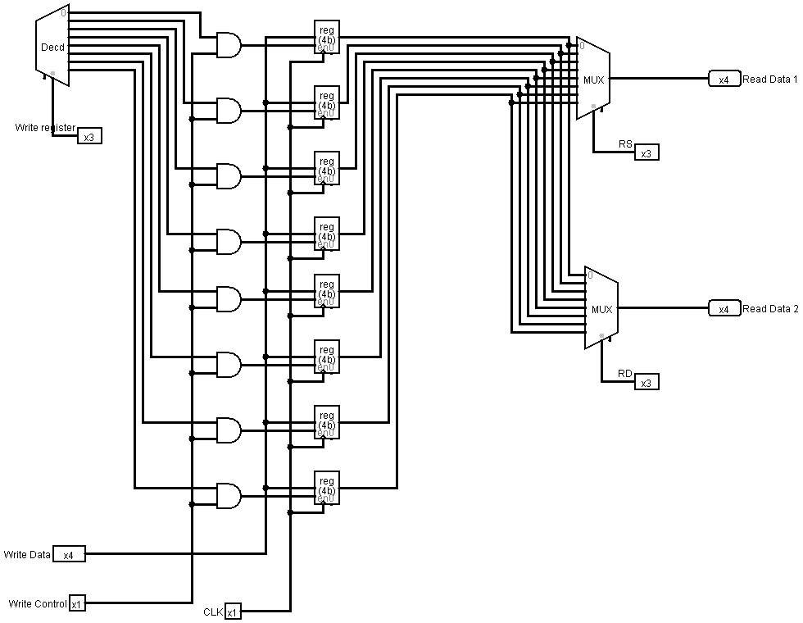

**Discussion:**

After completing the lab, we got a clear idea to build a 4-bit Register File and get the clear conception of its function. We built a circuit in the Logisim, firstly we use a decoder to select which register will be selected to write data. For the decoder, we take a 3-bit Selection Pin labelled as “Write Register”. Then, we take 8 AND gates and 8 4-bit Register. From the decoder we get 8 outputs which will be connected to the 1st input of all the AND gates. Then we take a 1-bit input labeled as “Write Control” which will be connected with all the AND gate’s 2nd input. The output of the 8 AND gates will be connected to the Enable Pin of all the Register. Then, we take a 4-bit input labeled as “Write Data” which will be connected to the input of all the Register. We will take a clock and connect it to the “Clock” of all the Register. We take two MUX of data bit 8 with 3-bit Selection Pin. We connect the outputs of all the Register respectively to 2 multiplexers. Then, we take two different 3-bit Selection Pin for both of the multiplexers respectively labeled as “RS” and “RD”. Finally, we get two 4-bit output from both of the multiplexers which are labeled as “Read Data 1” and “Read Data 2” respectively.